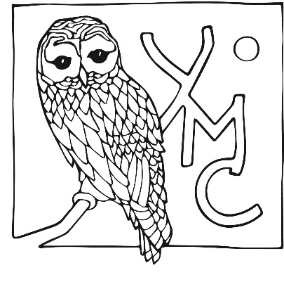
Yew Mountain Center
Acknowledgment of Personal Responsibility and Waiver
The Yew Mountain Center (YMC) is excited to welcome participants for fun and educational experiences on our property. We will do our best to ensure that everyone has a safe adventure with us, but all participants and guardians should be aware of the risks that are inherent in outdoor experiences. Forests, meadows, and creeks have obstacles, uneven terrain, slippery surfaces, and are habitats for wild animals.
Due to insurance requirements, we ask all adults and youths to sign this waiver in order to participate in our programs.

I certify that _____________________________________ I am able to handle physical demands
(participant’s name)

of participating in ___________________________________________. I assume all risks
(program name)
associated this program including, but not limited to, falls, contact with other participants, falling branches, the effects of extreme weather, trail conditions, and water hazards. If I choose to swim or boat on the property, I do so at my own risk. I understand that there is no lifeguard on duty. I understand that it is my responsibility to come prepared for any weather conditions. Should an injury occur, YMC will take reasonable steps to assist the injured party and acquire appropriate medical attention. All medical fees are the responsibility of the participant or participant’s guardian.
I hereby for the participant, or anyone else who might claim on his or her behalf, release, discharge, hold harmless, covenant not to sue, the organizer of this program, the Yew Mountain Center, Inc., or Lobelia L.L.C., and any individual and organization associated with this educational event, from claims of liability for death, personal injury, or property damage or loss.
______________________ ___________________________
Participant First and Last Name

X____________________________________________________ _________________
Participant Signature Date

X____________________________________________________ _________________
Parent/ Guardian Signature (if participant is a minor) Date

I grant permission to use any photographs, video recordings, or any other record of this event for any legal purpose. _________
Yes No Initial
Yew Mountain Center Experience
9494 Lobelia Road Hillsboro, WV 24946 Learning, Education, and Living Well in
304-653-4079 Appalachia
www.yewmountain.org

